Lab # 7
Behavioral Patterns: Chain of Responsibility Pattern and Command Pattern
OBJECTIVE
Understand behavioral design patterns: Chain of responsibility Pattern and Command Pattern
Exercise
Implement Chain of responsibility Pattern and Command Pattern on your selected scenario.
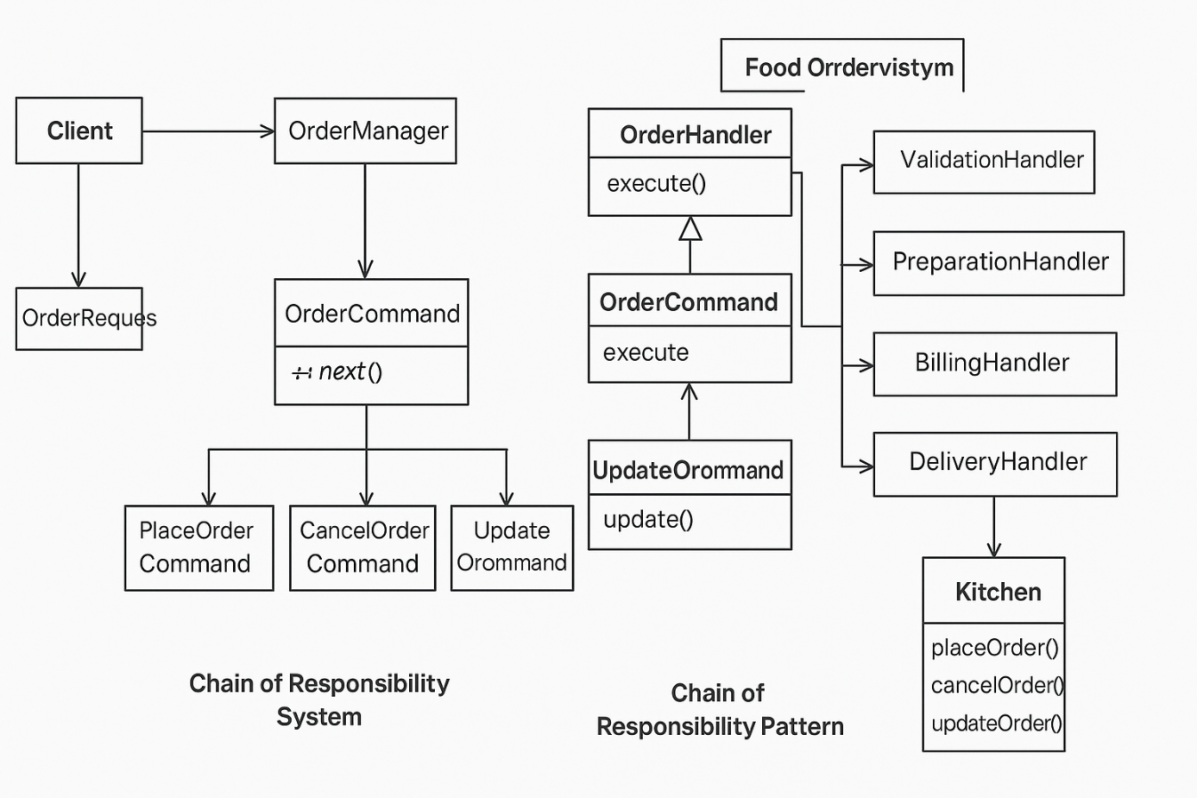

CODE :
import java.util.ArrayList;
import java.util.List;

// Abstract Handler for Chain of Responsibility Pattern
public abstract class OrderHandler {
protected int level;
protected OrderHandler nextHandler;

public void setNextHandler(OrderHandler nextHandler) {
this.nextHandler = nextHandler;
}

public void handleOrder(int level, String order) {
if (this.level <= level) {
processOrder(order);
}
if (nextHandler != null) {
nextHandler.handleOrder(level, order);
}
}

protected abstract void processOrder(String order);
}

// Concrete Handlers for Chain of Responsibility Pattern
class TakeOrderHandler extends OrderHandler {
public TakeOrderHandler(int level) {
this.level = level;
}

@Override
protected void processOrder(String order) {
System.out.println("Taking Order: " + order);
}
}

class PrepareOrderHandler extends OrderHandler {
public PrepareOrderHandler(int level) {
this.level = level;
}

@Override
protected void processOrder(String order) {
System.out.println("Preparing Order: " + order);
}
}

class ServeOrderHandler extends OrderHandler {
public ServeOrderHandler(int level) {
this.level = level;
}

@Override
protected void processOrder(String order) {
System.out.println("Serving Order: " + order);
}
}

// Command Interface for Command Pattern
interface Command {
void execute();
}

// Receiver Class for Command Pattern
class FoodOrder {
private String foodName;

public FoodOrder(String foodName) {
this.foodName = foodName;
}

public void placeOrder() {
System.out.println("Placing Order: " + foodName);
}

public void prepareOrder() {
System.out.println("Preparing: " + foodName);
}

public void deliverOrder() {
System.out.println("Delivering: " + foodName);
}
}

// Concrete Command Classes for Command Pattern
class PlaceOrderCommand implements Command {
private FoodOrder foodOrder;

public PlaceOrderCommand(FoodOrder foodOrder) {
this.foodOrder = foodOrder;
}

@Override
public void execute() {
foodOrder.placeOrder();
}
}

class PrepareOrderCommand implements Command {
private FoodOrder foodOrder;

public PrepareOrderCommand(FoodOrder foodOrder) {
this.foodOrder = foodOrder;
}

@Override
public void execute() {
foodOrder.prepareOrder();
}
}

class DeliverOrderCommand implements Command {
private FoodOrder foodOrder;

public DeliverOrderCommand(FoodOrder foodOrder) {
this.foodOrder = foodOrder;
}

@Override
public void execute() {
foodOrder.deliverOrder();
}
}

// Command Invoker Class
class Waiter {
private List<Command> commandList = new ArrayList<>();

public void takeOrder(Command command) {
commandList.add(command);
}

public void placeOrders() {
for (Command command : commandList) {
command.execute();
}
commandList.clear();
}
}

// Demo Class for Chain of Responsibility and Command Pattern
public class FoodOrderingSystem {

// Method to get the Chain of Responsibility
private static OrderHandler getOrderChain() {
OrderHandler takeOrderHandler = new TakeOrderHandler(1);
OrderHandler prepareOrderHandler = new PrepareOrderHandler(2);
OrderHandler serveOrderHandler = new ServeOrderHandler(3);

takeOrderHandler.setNextHandler(prepareOrderHandler);
prepareOrderHandler.setNextHandler(serveOrderHandler);

return takeOrderHandler;
}

public static void main(String[] args) {
// Demonstrating Chain of Responsibility Pattern
OrderHandler orderChain = getOrderChain();
System.out.println("Ordering a Pizza...");
orderChain.handleOrder(1, "Pizza");

System.out.println("\nOrdering a Burger...");
orderChain.handleOrder(2, "Burger");

System.out.println("\nOrdering a Salad...");
orderChain.handleOrder(3, "Salad");

// Demonstrating Command Pattern
FoodOrder pizzaOrder = new FoodOrder("Pizza");
FoodOrder burgerOrder = new FoodOrder("Burger");

Command placePizzaOrder = new PlaceOrderCommand(pizzaOrder);
Command preparePizzaOrder = new PrepareOrderCommand(pizzaOrder);
Command deliverPizzaOrder = new DeliverOrderCommand(pizzaOrder);

Command placeBurgerOrder = new PlaceOrderCommand(burgerOrder);
Command prepareBurgerOrder = new PrepareOrderCommand(burgerOrder);
Command deliverBurgerOrder = new DeliverOrderCommand(burgerOrder);

Waiter waiter = new Waiter();

waiter.takeOrder(placePizzaOrder);
waiter.takeOrder(preparePizzaOrder);
waiter.takeOrder(deliverPizzaOrder);

waiter.takeOrder(placeBurgerOrder);
waiter.takeOrder(prepareBurgerOrder);
waiter.takeOrder(deliverBurgerOrder);

waiter.placeOrders();
}
}

OUTPUT :
